**EXPERIMENT 7**

DATE: 02.03.24

Write the python program to implement BFS.

**AIM:**

The aim is to implement the BFS algorithm using python program.

**PROGRAM:**

from collections import defaultdict

class Graph:

def __init__(self):

self.graph = defaultdict(list)

def add_edge(self, u, v):

self.graph[u].append(v)

def BFSUtil(self, v, visited):

visited.add(v)

queue = [v]

while queue:

v = queue.pop(0)

print(v, end=' ')

for neighbor in self.graph[v]:

if neighbor not in visited:

queue.append(neighbor)

visited.add(neighbor)

def BFS(self, v):

visited = set()

self.BFSUtil(v, visited)

g = Graph()

g.add_edge(0, 1)

g.add_edge(0, 2)

g.add_edge(1, 2)

g.add_edge(2, 3)

g.add_edge(3, 4)

print("Breadth First Traversal (starting from vertex 0):")

g.BFS(0)

**INPUT:**

Starting_node=’A’

**OUTPUT:**

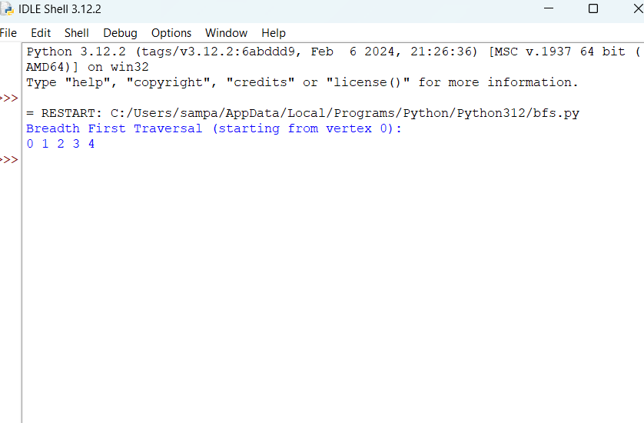

**RESULT:**

BFS algorithm using python executed successfully.